✴

**Build empathy**

The information you add here should be representative of the observations and research you've done about your users.

Empathy map

Use this framework to develop a deep, shared understanding and empathy for other people. An empathy map helps describe the aspects of a user's experience, needs and pain points, to quickly understand your users’ experience and mindset.

# Says

What have we heard them say? What can we magine them saying?

The thyroid disease is typically based on the underlying cause and the resulting abnormal thyroid function.

# Thinks

What are their wants, needs, hopes, and dreams? What other thoughts might influence their behavior?

Treatment for any underlying conditions that may be contributing to their thyroid dissease.

potential developments or innovations that could impact the thyroid disease.

Effective and timely diagnosis of thyroid disease.

Thyroid disease classification

Thyroid disease will experience all of these symptoms.

People with thyroid disease may worry that they won't be able to control their symptoms.

Fatigue, Weight changes, Hair and skin changes, etc,

Fear of surgery is may require surgery to remove part or all of the thyroid gland.

[**Share template feedback**](https://muralco.typeform.com/to/CiqaHVat?typeform-source=app.mural.co)

# Does

What behavior have we observed? What can we imagine them doing?

# Feels

What are their fears, frustrations, and anxieties? What other feelings might

influence their behavior?

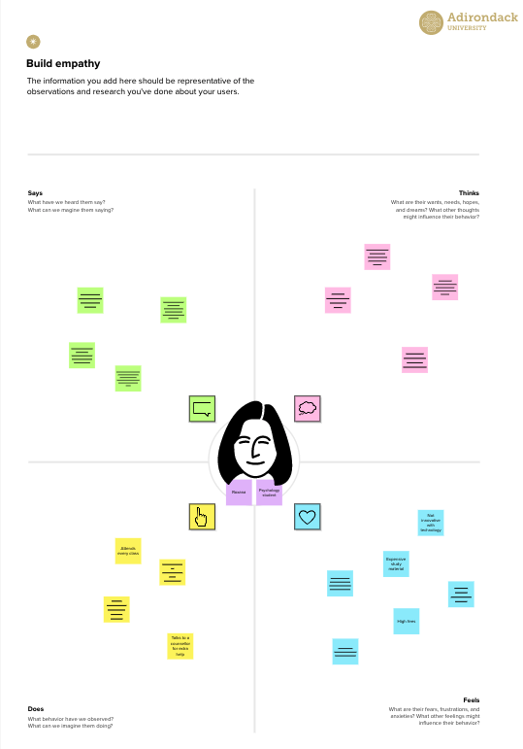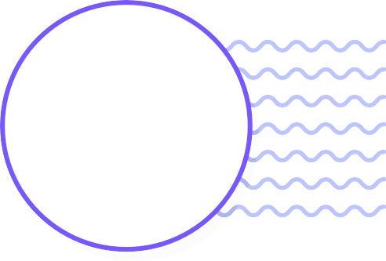

**Template**

**Need some inspiration?**

See a finished version of this template to kickstart your work.

[**Open example**](https://app.mural.co/template/f44b7843-7c23-408c-bd36-7b0c9409dc20/96efd10c-81d2-401e-8072-4e87935e5d6b)